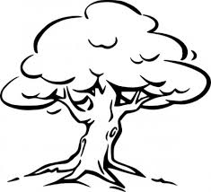
Biological Science Year 7
Mid Topic Test
Name: _______________________________________ Total: 70 marks
Part A: Multiple-Choice (10 marks)
1. Which of the following all belong to the phylum Arthropoda?
A ants, bees, grasshoppers, crabs and spiders.
B snails, ticks, moths, prawns and worms.
C birds, bees, ants, butterflies and snails.
D earthworms, flatworms, roundworms and tapeworms.

2. At each stage in a dichotomous key there are:
A four choices.
B two choices.
C two or three choices.
D one choice.
3. When writing a classification key for people, a strong feature would be something like:
A hair length.
B hair colour.
C eye colour.
D all of the above.
4. Which of the following shows the order of classification from largest group to smallest group?
A kingdom, phylum, class, order, family, genus, species.
B species, genus, family, order, class, phylum, kingdom.
C kingdom, phylum, order, class, family, species, genus.
D genus, species, order, family, class, phylum, kingdom.
5. The five kingdoms are:
A animal, plant, protest, arthropod and fungi.
B animal, plant, porifera, monera and fungi.
C animal, plant, protest, monera and aves.
D animal, plant, protest, monera and fungi.

6. All Cnidaria have the following characteristics:
A live in water, bilateral symmetry and a backbone.
B live in water, radial symmetry and stinging cells.
C radial symmetry, live on land and have a backbone.
D bilateral symmetry, segmented bodies and live in damp areas.
7. The plant kingdom is broken into three divisions based on:
A the way they reproduce and their transport system.
B if they have flowers or not.
C their colour and the way they reproduce.
D if they have seeds or not.

8. Mammals are broken into the following groups:
A marsupials, monotremes and agnatha.
B monera, monotremes and placentals.
C marsupials, monotremes and placentals.
D marsupials, monotremes and endoderms.

9. The three phyla to which worms belong are:
A nematode, mollusc and annelid.
B chordate, platyhelminthes and annelid.
C nematode, platyhelminthes and arthropod.
D nematode, platyhelminthes and annelid.

10. The scientific name of an organism tells you its:
A genus and species.
B class and species.
C kingdom and phylum.
D order and family.

Part 2: Short Answer
1. Match the following terms with their correct meaning. Note: not all words will be used.
Classification, taxonomist, dichotomous key, taxonomy, kingdom, class, phylum, microscopic, macroscopic, multicellular, unicellular, amphibians, reptiles, aves, mammals, chordates, conifers, endoskeleton, exoskeleton, molluscs, parasite, flowering plant,

a) Made of many cells _______________________________________________________

b) Cannot be seen with the naked eye ___________________________________________

c) A key with two choices at each stage __________________________________________

d) The process of putting things into groups _______________________________________

e) An organism that lives on or in another organism ________________________________

f) A scientist that specialises in grouping and naming things __________________________

g) The first level of classification _______________________________________________

h) Plants that have seeds in cones _______________________________________________

i) Class of chordates that contains frogs __________________________________________

j) Animals with a nerve cord running down their back ______________________________

(10 marks)

2. a) Draw and label a dichotomous key for the shapes below:

(5 marks)
b) Describe how a dichotomous key is different to other keys ___________________________

___________________________________________________________________________

___________________________________________________________________________

___________________________________________________________________________
(2 marks)

3. Chordates are one phyla of the animal kingdom. Answer the following questions about chordates:

- State the unique characteristic of marsupials ? ____________________________

- State which class snakes belong to? __________________________________________

- List two classes of chordate you have not already used ____________________________

(4 marks)

4. Justify the following statement:

- Platypus are mammals, however, they are not in the same subclass as most other mammals.
___________________________________________________________________________

___________________________________________________________________________

___________________________________________________________________________

(2 marks)

5. Explain how organisms are given their scientific name: ______________________________

___________________________________________________________________________

___________________________________________________________________________

(2 marks)

6. Classify the following as radial or bilateral symmetry:

- starfish _________________________________________
- jellyfish ___________________________________________
- earthworms _________________________________________
- humans ______________________________________
(4 marks)

7. Identify one example of an individual in the following phylum:

- Poriferan _____________________________________
- Cniderian _____________________________________
- Mollusc ______________________________________
- Echinoderm ___________________________________
- Arthropod _____________________________________
(5 marks)

8. The following picture shows some Australian owls. Mask refers to the face shape.
Answer the questions on the following page using the key. 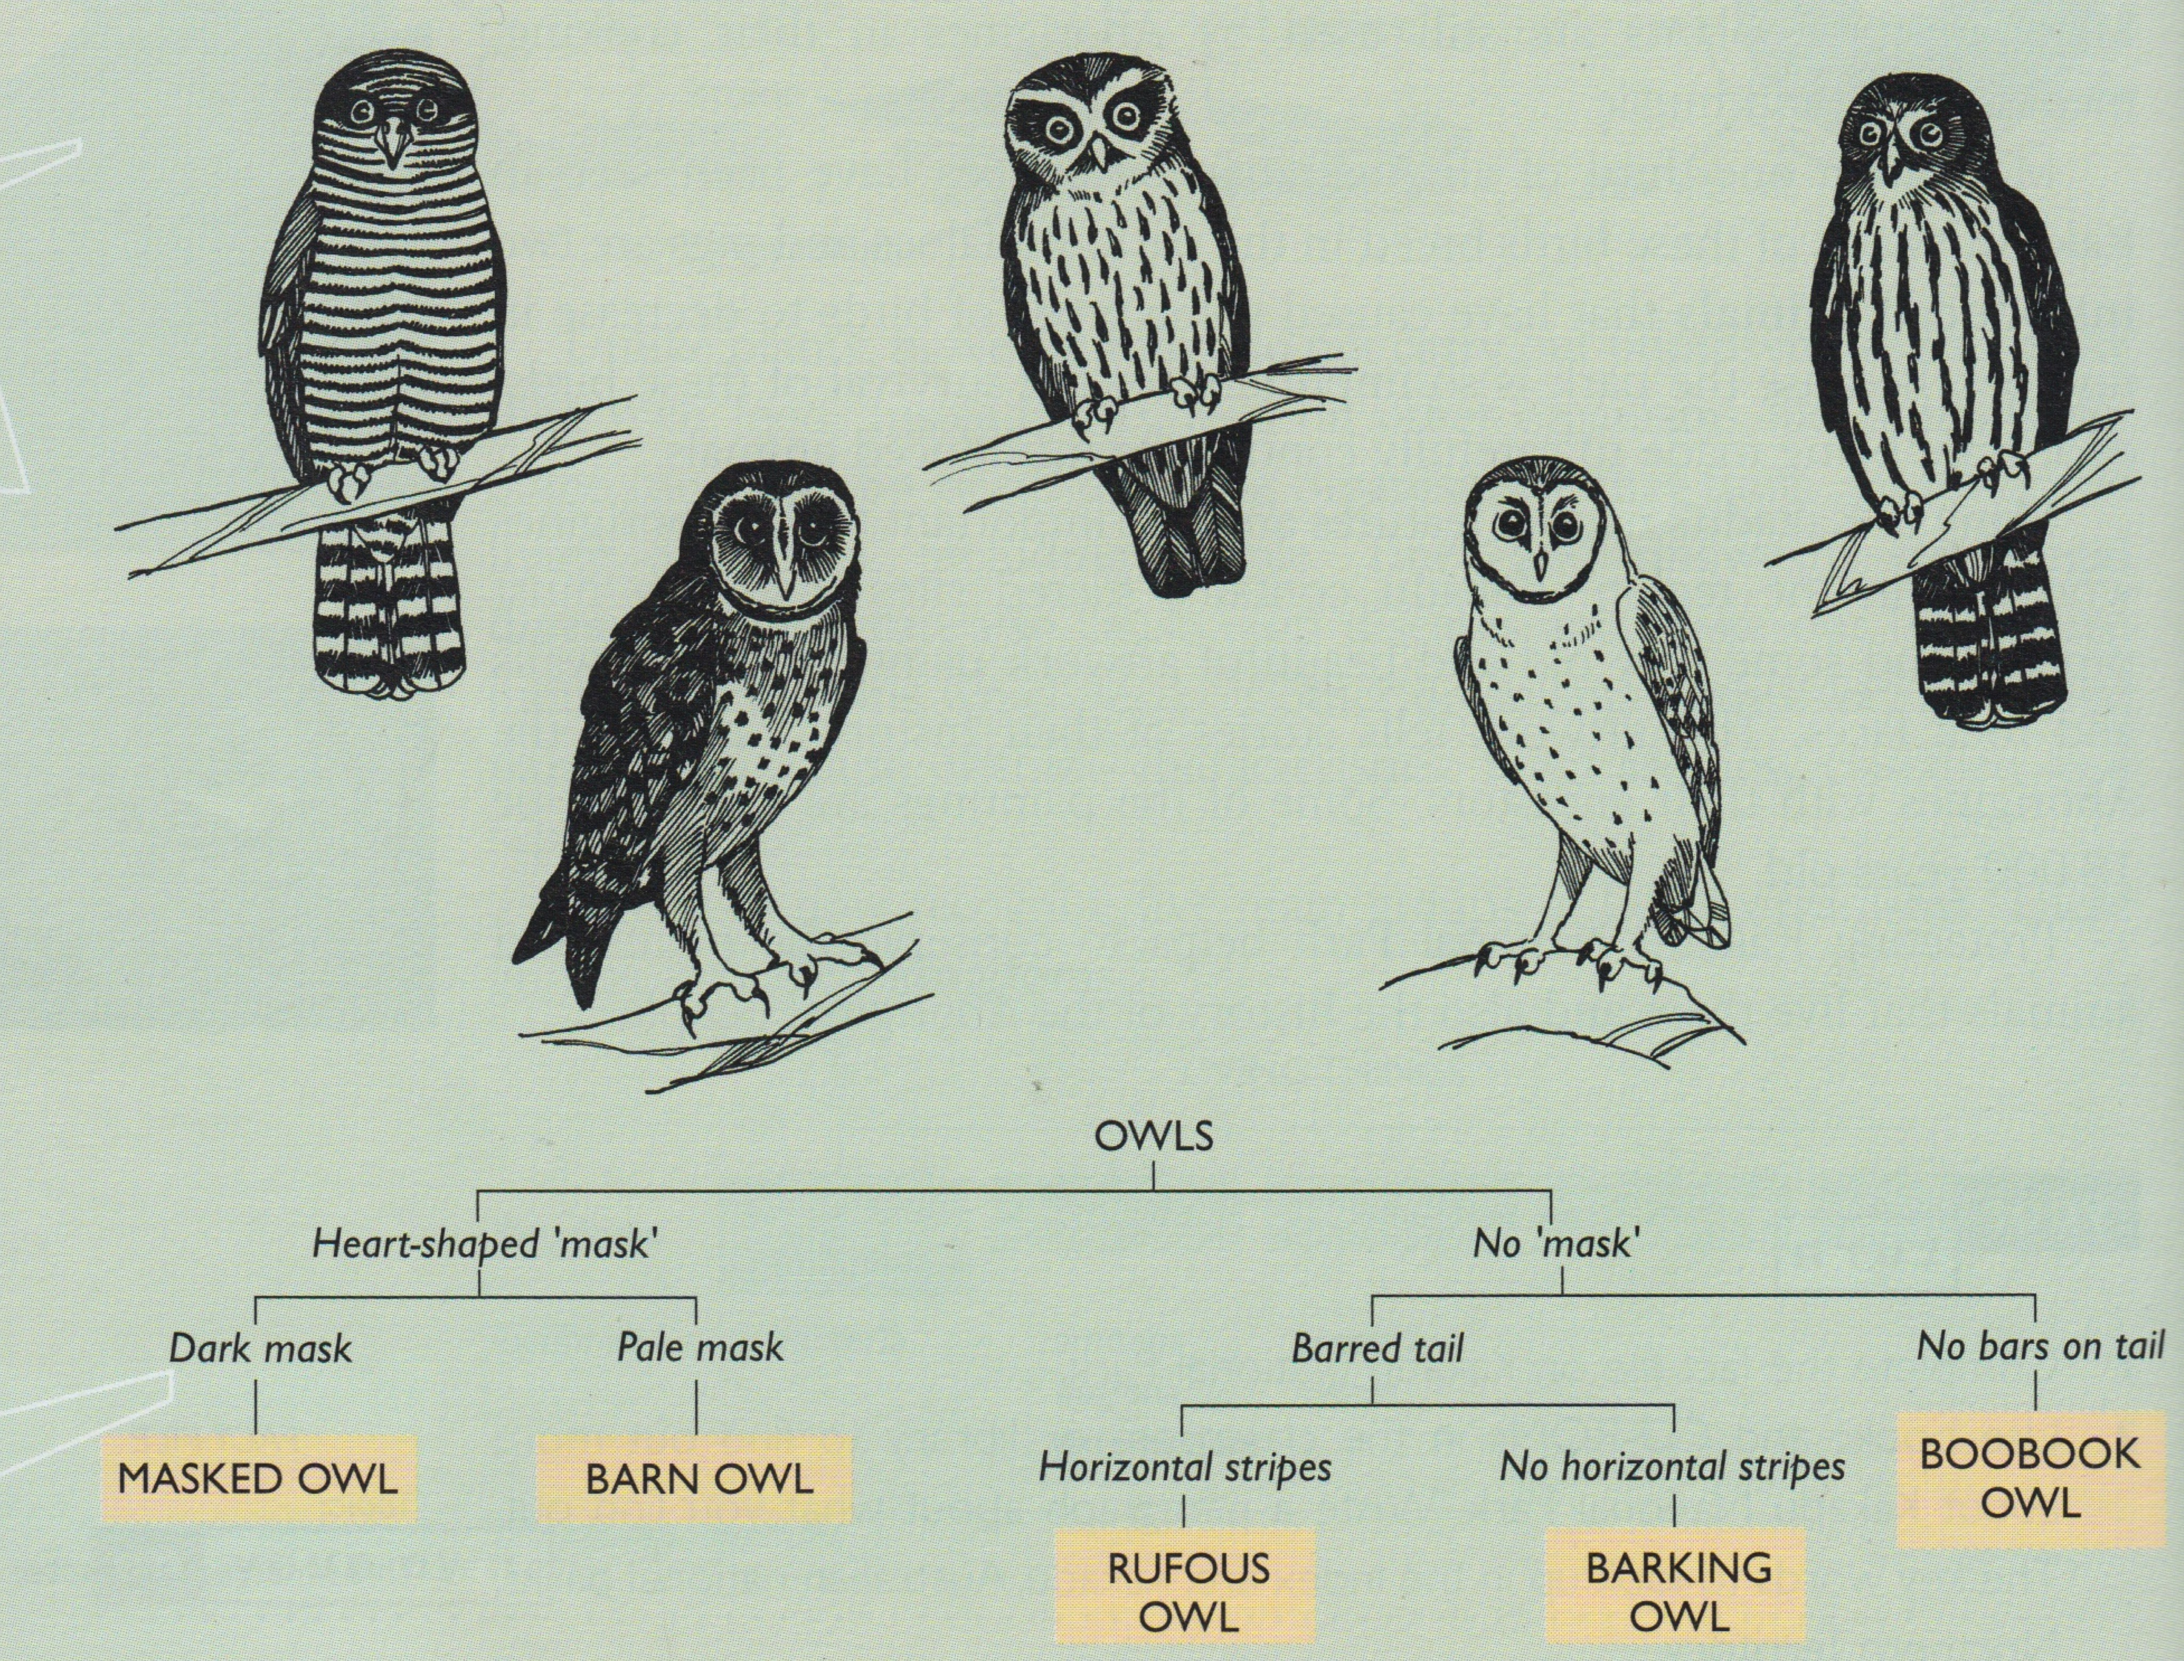

a) Use the key to identify each owl. Write their name next to their picture on the key.
(5 marks)
b) Identify one other feature that could be used to classify any of the owls _________________

___________________________________________________________________________
(1 mark)
c) State why this key is a ‘strong’ key ______________________________________________

___________________________________________________________________________

___________________________________________________________________________
(1 mark)

9. The following table shows the number of identified species in each phylum.

Phylum | Number of species in the phylum
Porifera | 500
Cnidaria | 9 000
Nematoda | 20 000
Arthropoda | 1 230 000+
Platyhelminthes | 20 000
Mollusca | 100 000
Annelida | 15 000
Echinodermata | 7 000
Chordata | 52 675

a) Graph the results above as a column graph. (5 marks)

b) Which two phyla have the least number of species ____________________________

___________________________________________________________________________
(2 mark)

c) Which two phyla have the most number of species ____________________________

___________________________________________________________________________
(2 mark)
d) Compare Platyhelminthes and Mollusca ___________________________________

___________________________________________________________________________

___________________________________________________________________________
(2 marks)
e) If scientists were to find and name 52 new species in the phylum Porifera, estimate the percentage increase this would represent

__________________________________________________________________________ (1 mark)
f) Explain why the number of species increase every year.

___________________________________________________________________________

___________________________________________________________________________

___________________________________________________________________________

___________________________________________________________________________
(2 mark)

10. Define the following:

i) exoskeleton ___________________________________________________________

___________________________________________________________________________

ii) monotreme ___________________________________________________________

___________________________________________________________________________

iii) fungi _________________________________________________________

___________________________________________________________________________

iv) vertebrate ____________________________________________________________

___________________________________________________________________________

v) endothermic __________________________________________________________

___________________________________________________________________________
(5 marks)

